**March 2024**

**Science News**

**Welcome to the re-launch of our Science Newsletter at St Augustine’s.**

**In each newsletter, we will share important science news from throughout the school and the world; some examples of the children’s science; publish dates of science-based events that may be of interest and share some science activities that will hopefully inspire you to do more science at home too.**

**We hope to publish a newsletter termly**!

**Science at home!** 

**Can you grow a plant?**

In spring, plants pop up everywhere. Grow your own and observe what happens.

**What you need:**

* Clear cup or container for planting
* Marbles, stones or pebbles
* Water
* Plant bulb

**What to do:**

1. Fill a [clear container](http://www.amazon.com/gp/product/B002YD8GCA/ref=as_li_ss_tl?ie=UTF8&camp=1789&creative=390957&creativeASIN=B002YD8GCA&linkCode=as2&tag=buggyandbuddy-20) about 3/4 full with [rocks](http://www.amazon.com/gp/product/B000YJ2XXO/ref=as_li_ss_tl?ie=UTF8&camp=1789&creative=390957&creativeASIN=B000YJ2XXO&linkCode=as2&tag=buggyandbuddy-20), marbles, or pebbles.
2. Place the bulb on top. (Be sure you put the bulb in the container root side down.)
3. Fill the glass with water until it’s just barely covering the bottom of the bulb.
4. Place the bulb in a sunny window.
5. Continue observing the bulb each day and watch what happens. Be sure to add water to the container as the water level begins to go down.
6. Record your observations each week.

By planting a bulb in a clear container with stones, you’ll be able to observe the roots growing, as well as observe the plant growing above the rocks.

**ALWAYS ask an adult to help you**

**Science Ambassadors**

**So far this year, we have selected 8 children from year 3,4, 5 and 6 to be our Science Ambassadors. This is a new role this year and involves lots of responsibilities such as helping with the science newsletter, running science competitions and helping Miss Ford to improve and increase opportunities for scientific learning within our school. We hope that in the near future, when it will be possible, this will also include taking part in leading assemblies and helping with British Science Week.**

**Our Science Ambassadors are:**

**Y3- William and Daria**

**Y4- Fraser and Rory**

**Y5- Maria and John**

**Y6- Fintan and Anna**

**Why not try something new?**

**Have a go at some fun STEM activities with LEGO or create your own species!**

[**https://education.theiet.org/first-lego-league-programmes/**](https://education.theiet.org/first-lego-league-programmes/)

[**https://www.linnean.org/learning/special-species**](https://www.linnean.org/learning/special-species)

**Scientists in Training!**

**At St Augustine’s, we are proud of all the amazing work we do, especially in Science. Here are some photos to share what we have been up to.**

**Science news around the world**

**Threats to the Antarctic**

The huge frozen landmass at the bottom of our planet is more than just spectacular icing on the globe. The Antarctic ice deflects some of the sun's rays away from the Earth, keeping our world's climate in balance.

|  |  |  |  |  |  |  |  |
| --- | --- | --- | --- | --- | --- | --- | --- |
| |  |  |  |  |  |  |  | | --- | --- | --- | --- | --- | --- | --- | | |  |  | | --- | --- | | |  | | --- | | ABOUT THE ANTARCTIC | | | |  | | --- | |  |  |  | | --- | |  |  |  | | --- | |  | | |
| |  | | --- | | The Antarctic is land surrounded by ocean, whereas the Arctic is ocean surrounded by land. Despite being the world's coldest, windiest and driest continent, with a record low temperature of -94C, it doesn't snow much. The Antarctic is so dry it's classed as a polar desert. The Antarctic is one of the world's least disturbed places, but it's increasingly vulnerable, especially to global warming and climate change. First of all, these incredible landscapes store vast amounts of our planet’s fresh water as ice. Unfortunately in the Arctic and parts of the Antarctic, it’s melting at an alarming rate and we’ve already seen a lot of Antarctic glaciers retreating in the last 50 years. On the west side of the Antarctic peninsula, almost 90% of glaciers are retreating and the main cause is warming ocean temperatures.  Meanwhile up at the Arctic, floating sea ice has been decreasing dramatically – it’s likely there will be virtually no sea ice there in summer months within a generation.  Our frozen poles also play a vital role in regulating the world’s climate. The white ice reflects some of the sun’s rays back into space, helping to keep the Earth at an even temperature. Sea Ice also helps to regulate the movements of warm and cold water around the oceans.  Melting ice means even more heat is absorbed by the ocean – which causes even faster melting, and could shift ocean currents.  Some of the planet’s most iconic animals live in these landscapes, including polar bears in the Arctic and penguins in the Antarctic. The Arctic is also home to over four million people – though no one lives permanently in the Antarctic. | |

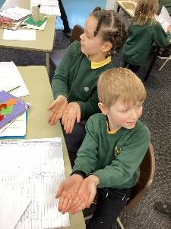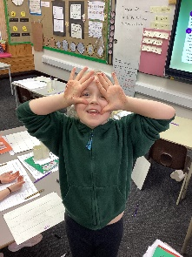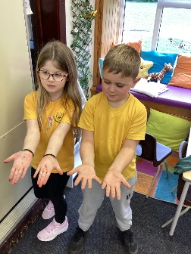

**Year 3 learning all about rocks.**

**I’d love to hear about all the science you have been doing at home!**

**Remember, photos can be sent into school through Dojo, I would love to know what you have been up to!**

**Miss Ford**

**Year 2 enjoying learning about germs and hygiene.**

**Year 4 conducted an experiment on tooth decay.**

**Reception making observations about winter.**

